2023 Mid-Year Review Doc

Name/Title: | Jonathan Kidder – Senior Recruiter
Date of Doc: | 05/15/2023

Purpose:
The purpose of this document is to summarize data, metrics, analyze outcomes, and identify growth opportunities in 2023.

Summary of Accomplishments for 2022 & 2023
In 2022, I was Promoted to L6 Senior Recruiter. YTD, I was able to get 44 offer accepts within Amazon Transportation Services (ATS) raising the bar for hire and develop the best. Highlights include: hiring a SDM L7 (Female) lead for Sort Tech and creating an SDM sourcing strategy with Mike Lindahl (see appendix A).

Externally, I Published 3 new recruiting books titled: Productivity Hacks for Recruiters, How to Launch your Recruiting Career, and Webscraping Basics for Recruiters.

In 2023, I’ve support 2 team projects, started mentoring 4 co-workers in talent sourcing, and have been working on updating wiki within the Last Mile Org.

Opportunity for Growth in 2023:
My goal for 2023 is to become a Principal Technical Recruiter. This will involve writing a promotion document gathering metrics data, participating in larger scale projects, as well as partnering with other L7’s (PrinciPALS wiki) to understand the promotion process. I plan on meeting with my manager Rebecca Leonetti and my mentor Marc Hamel to create a plan.

Highlights
Accolades Received: 27
Received many positive accolades since I started training teams across Amazon. Overall, I’m pleased to know my presentations are making a large impact across the different business lines (see appendix D).

Training Presentations 2022:
Presented on a number of different topics and received several accolades (see appendix D).

Engagement Outreach: Partnered with Shilpa Sharma to create a 30-slide deck presentation.
Webscraping & Automation Tools: Created a sourcing automation tools 30-slide deck presentation.
Top Talent Sourcing Tools: Created a sourcing tools 30-slide deck presentation.
SDE III Sourcing Summit: Created a 60-slide deck and presented to the entire SDE L6 recruiting team.
Diversity Pro Class: Created a 40-slide deck training presentation on BLNA Boolean sourcing (see appendix for video link).

Projects - 2023
Worked on updating the SDE II calibration wiki for the Last Mile wiki
Mentoring 4 Recruiters in the Mentorship program
Creating a Diversity Session Training (S&B with Erica Trudeau)
Building Military Veteran Recruiting program with Neil McCarty
Creating 2 talent sourcing training events for AWS and G&A Tech
Creating a Diversity Resource tab with the Wiki Last Mile team

Awards:
- Recognized as a Top 50 Recruitment Influencer to follow in 2023 – RecruitCRM
- Insights from 25 Industry Experts and Thought Leaders – MATCHR
- Recognized as a Recruiting All-Star (Shikha Org) Sept 2022

Metrics FY’22
Delivery Metrics:
This has been my best year at Amazon despite primarily sourcing L6 and L7 roles - which pose significantly more challenges in terms of leveling guidelines, scope, and candidate quality (see appendix B).

Hires | YTD
Total Number of Inclines | 46
Offer Accepts | 44
Offer Accept Ratio | 95.6%

OAE Data:
The 2022 OAE target was 6.9 and I ended at 31.0 for the year. This is an average of 3.4 per month is significantly above yearly required goals (see appendix C).

Candidate Experience:
Candidate Experience | YTD
2&5 Promise (Head Goal 80%, Tail Goal 99%)
PS Head | 85.5%
PS Tail | 97%
Onsite Head | 86.6%
Onsite Tail | 98.9%
RHMD- Tech (80% Goal)
PS PRR | 74%

Diversity Numbers:
Metrics | Results | Goal
Female Tech | 17.9% | 19.91%
DEI Tech | 8.6% | 7.59%

Appendix:
(A)
Hiring Feedback Received:
Inclined (Female) SDM L7 Offer Acceptance:
“Congrats on the incline, well done!” – Head of Last Mile - Damien Islam-Frenoy

“Not only a fantastic recruiter but also a great partner to work with! Many more years of partnership! – Sr Software Manager - Matias Rudaz

HM Sourcing Strategy:
"Jonathan - thank you for being a great partner in recruiting SDMs earlier this year! You gave me a great process that I could follow for LinkedIn outreach, followed up proactively, and helped me build and work through the pipeline. And you were super-responsive to me and candidates to make everyone feel like we were your #1 priority. We filled 2 SDM roles in 90 days, which was great performance to help me build my team." – Mike Lindahl

SDE III Sourcing Summit:
“Jonathan thanks so much for presenting and being so generous to our audience with your books! Your knowledge is invaluable to the recruiting organization. I know recruiters walked away with lots of new tools to try!” Sr. Recruiting Manager - Talibah Dehaney

“Jonathan was recently a presenter at the 2022 SDE3 Recruiting Summit. By sharing his expertise as different sourcing techniques, he provided lasting and valuable insights to SDE recruiters across Amazon globally. The SDE3 Recruiting Summit was a success in large part because of Jonathan's contributions, and we appreciate his partnership and commitment to hiring and developing the best at Amazon.” - Adriana Montez

(B)
Recruiting Metrics (Confidential)
(C)
Recruiting QAE Metrics:
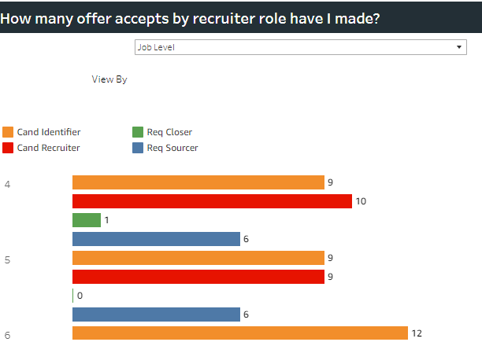
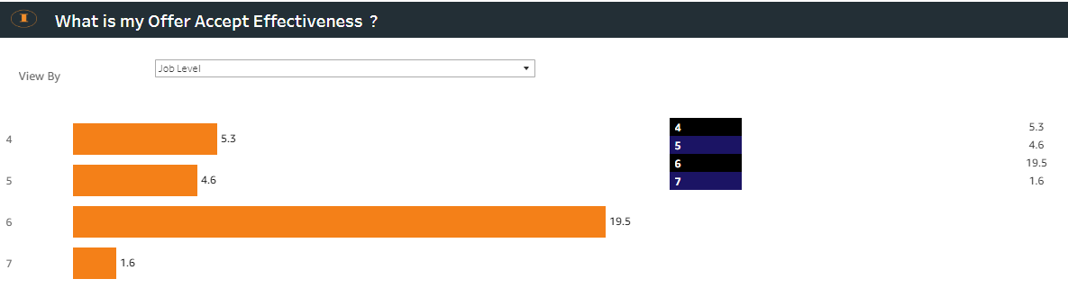
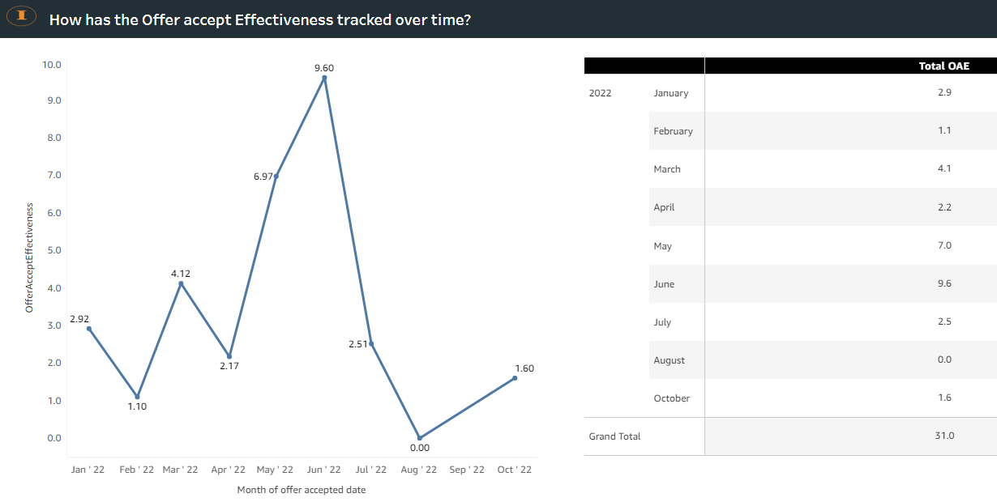
2&5 Metrics:
Diversity Numbers:
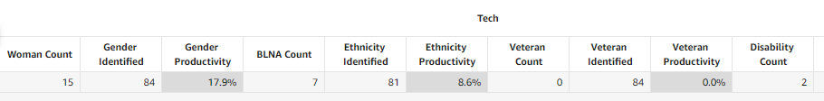
(D)
Training Accolades Received:
“Jonathan did a live presentation today on Diversity Sourcing for our team in Consumer Payments. He shared many tools and Boolean strings that will help us find a more diverse talent pool. His techniques are fresh and innovative that every Recruiter in Amazon should learn. Thank you, Jonathan! Great session!!” -Steven Schumacher

“Me and my entire team attended Jonathan training session on DEI sourcing and it went amazing. We all learned so much from him and the resources that he provided to the team. My team and myself are so ready to explore those new strings, websites and resources for our daily sourcing. He answered all the questions during the training and is always so ready to help just anyone. He is the best! Thank You Jonathan and appreciate you so much!” - Rachna Panchal

“Thank you so much for sharing your knowledge and time at the CGO TA DEI learning series. I was able to immediately take best practices from the session and put them into use in my own work flow. Embodying so many LP's. Additionally, I reached out to you after the session and your response was immediate and above and beyond what you needed to do. So grateful to be surrounded by coworkers like you!” - Andy Nagel
Diversity Training: https://broadcast.amazon.com/videos/543557
References:
Top Thought Leaders Post: https://www.matchr.io/top-sourcing-thought-leaders/#6_Jonathan_Kidder
Insights from 25 Industry Experts and Thought Leaders – MATCHR
https://www.matchr.io/recruitment-trends-2023/

17 Recruiting Books Published: https://www.amazon.com/Jonathan-Kidder/e/B08T8JNMN4/ref=dp_byline_cont_pop_ebooks_1

